  - Dear [Name]

I bought you a very special gift…a goat!!

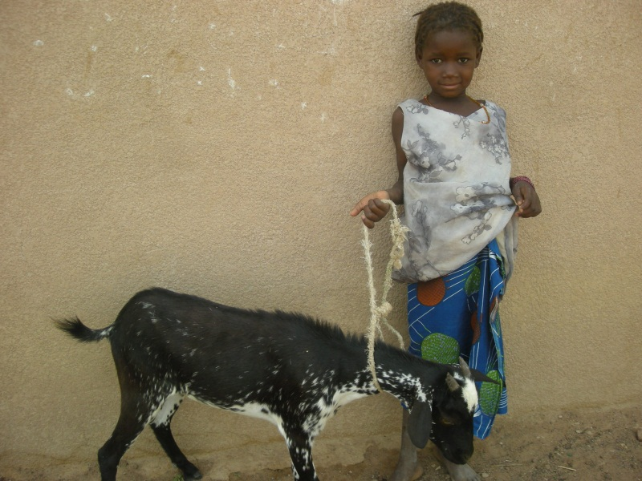

To celebrate your (birthday/graduation/thank you etc) this goat will save one little girl. Because of you, she will now have a proud future, free from pain and infection, and more importantly, she will now have the right to her own body.

To see the amazing good you have just done with this goat, please visit www.rightsofgirls.com

From: (your name) email address

